Tokyo2020 Sample

Tony Bao

Olympic Channel

https://play.google.com/store/apps/details?id=com.olympicchannel.olympics&hl=en

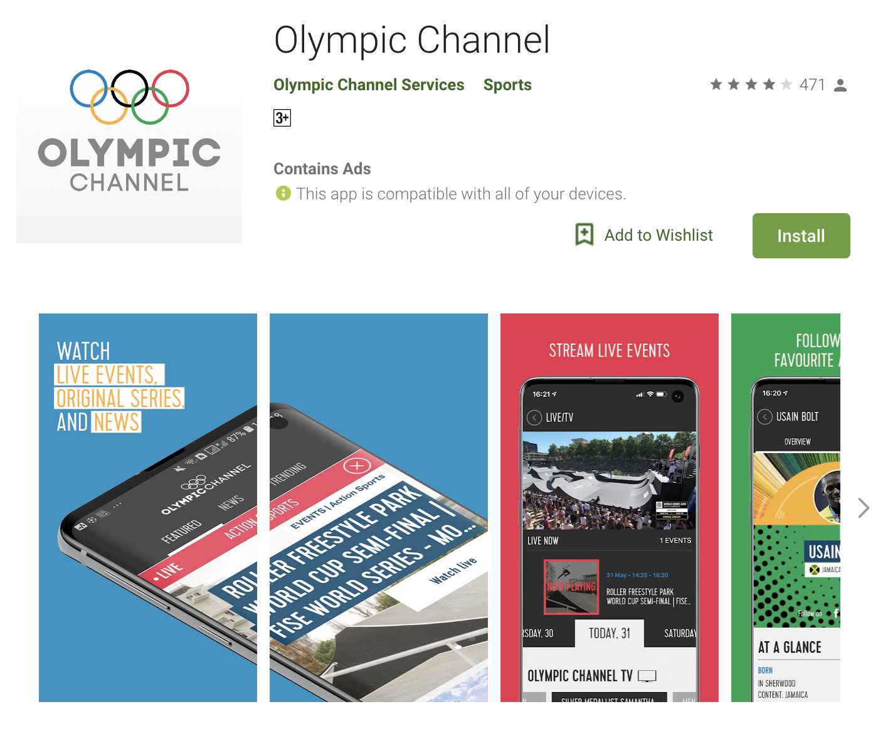

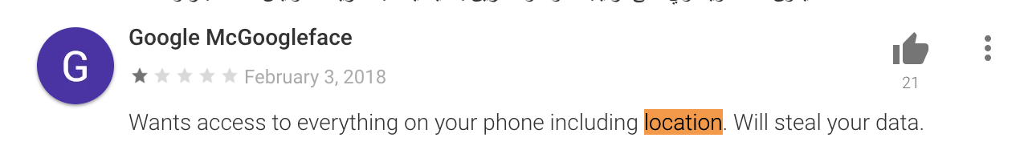

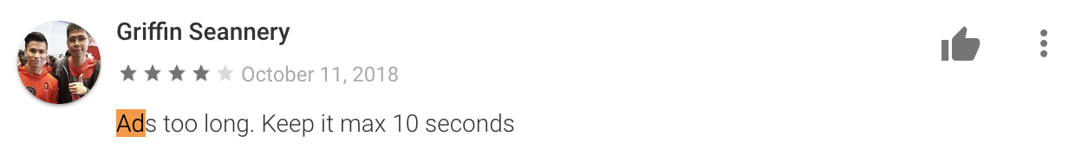

Steal Info Behavior

* Location

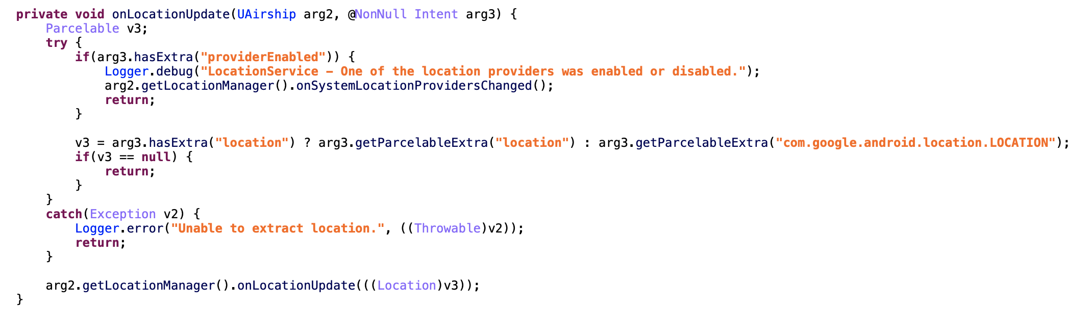



* Device Info

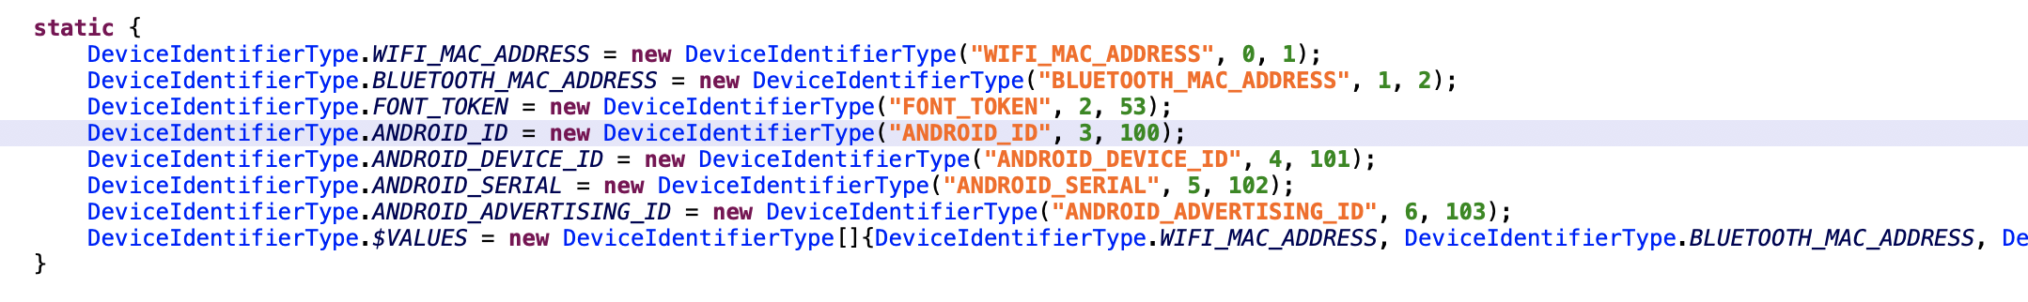

* Trace Screen

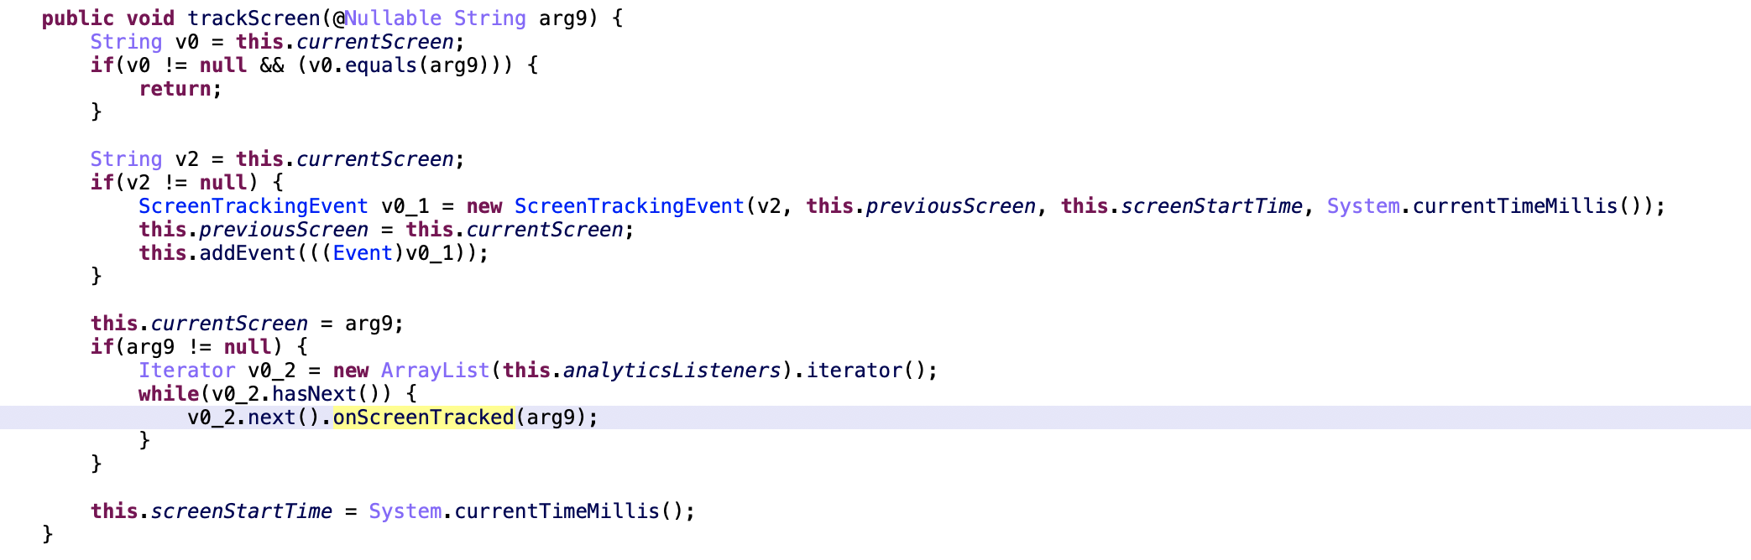

* Send All Info

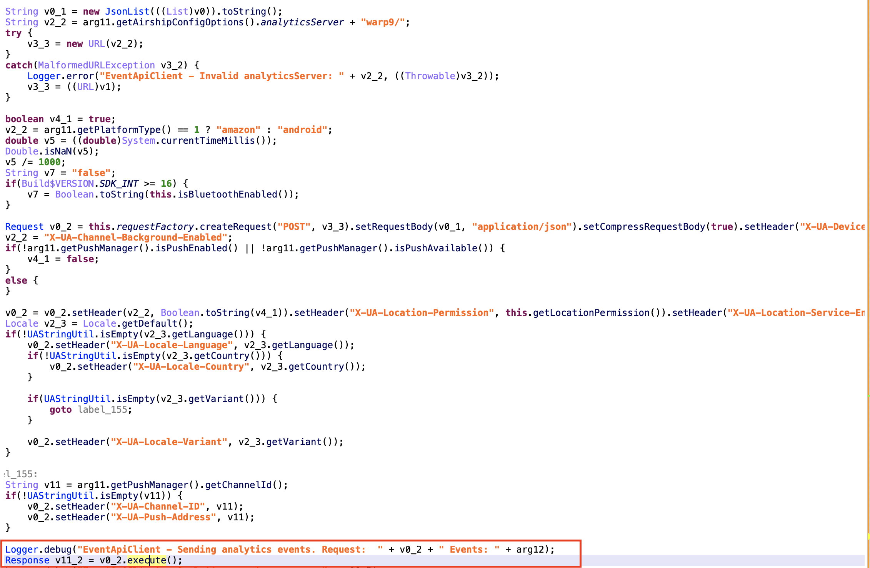

Olympic Games Wallpaper Themes

https://play.google.com/store/apps/details?id=com.Olympic.Games.Wallpaper.Themes.Dr&hl=en

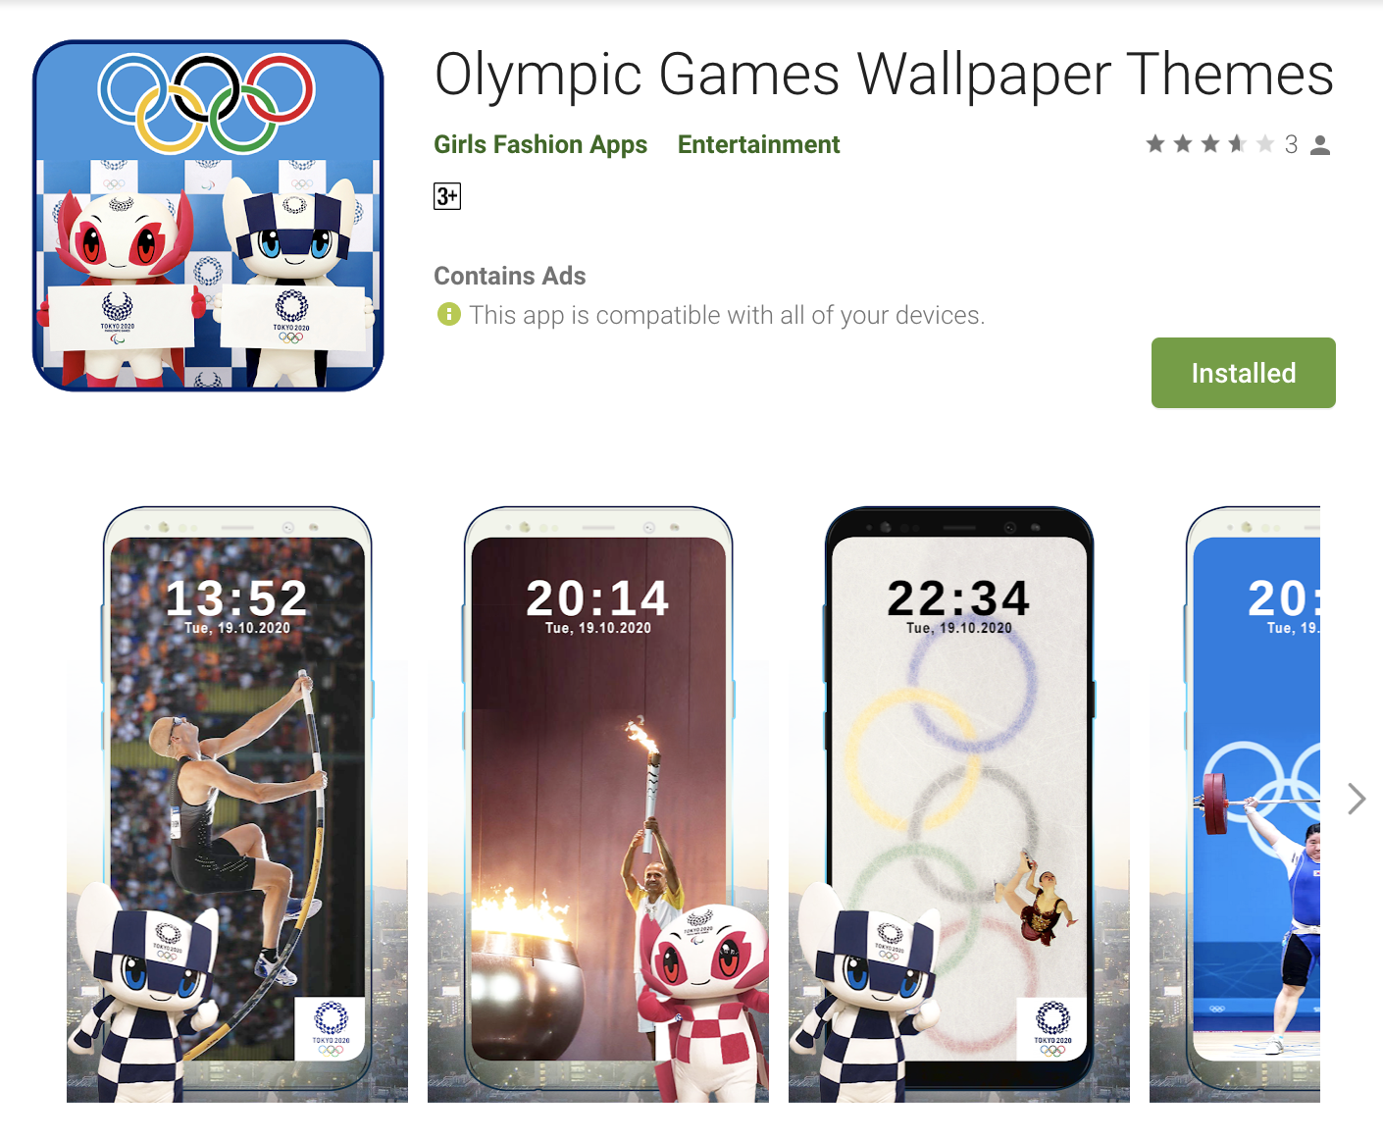

Adware

Mute and Full Screen Ad, some Ad can’t close button, some Ad show too long time and when you press the back button, you will return to the ad page.

